SDP 16 Treasure Box Braille UML Class Diagrams

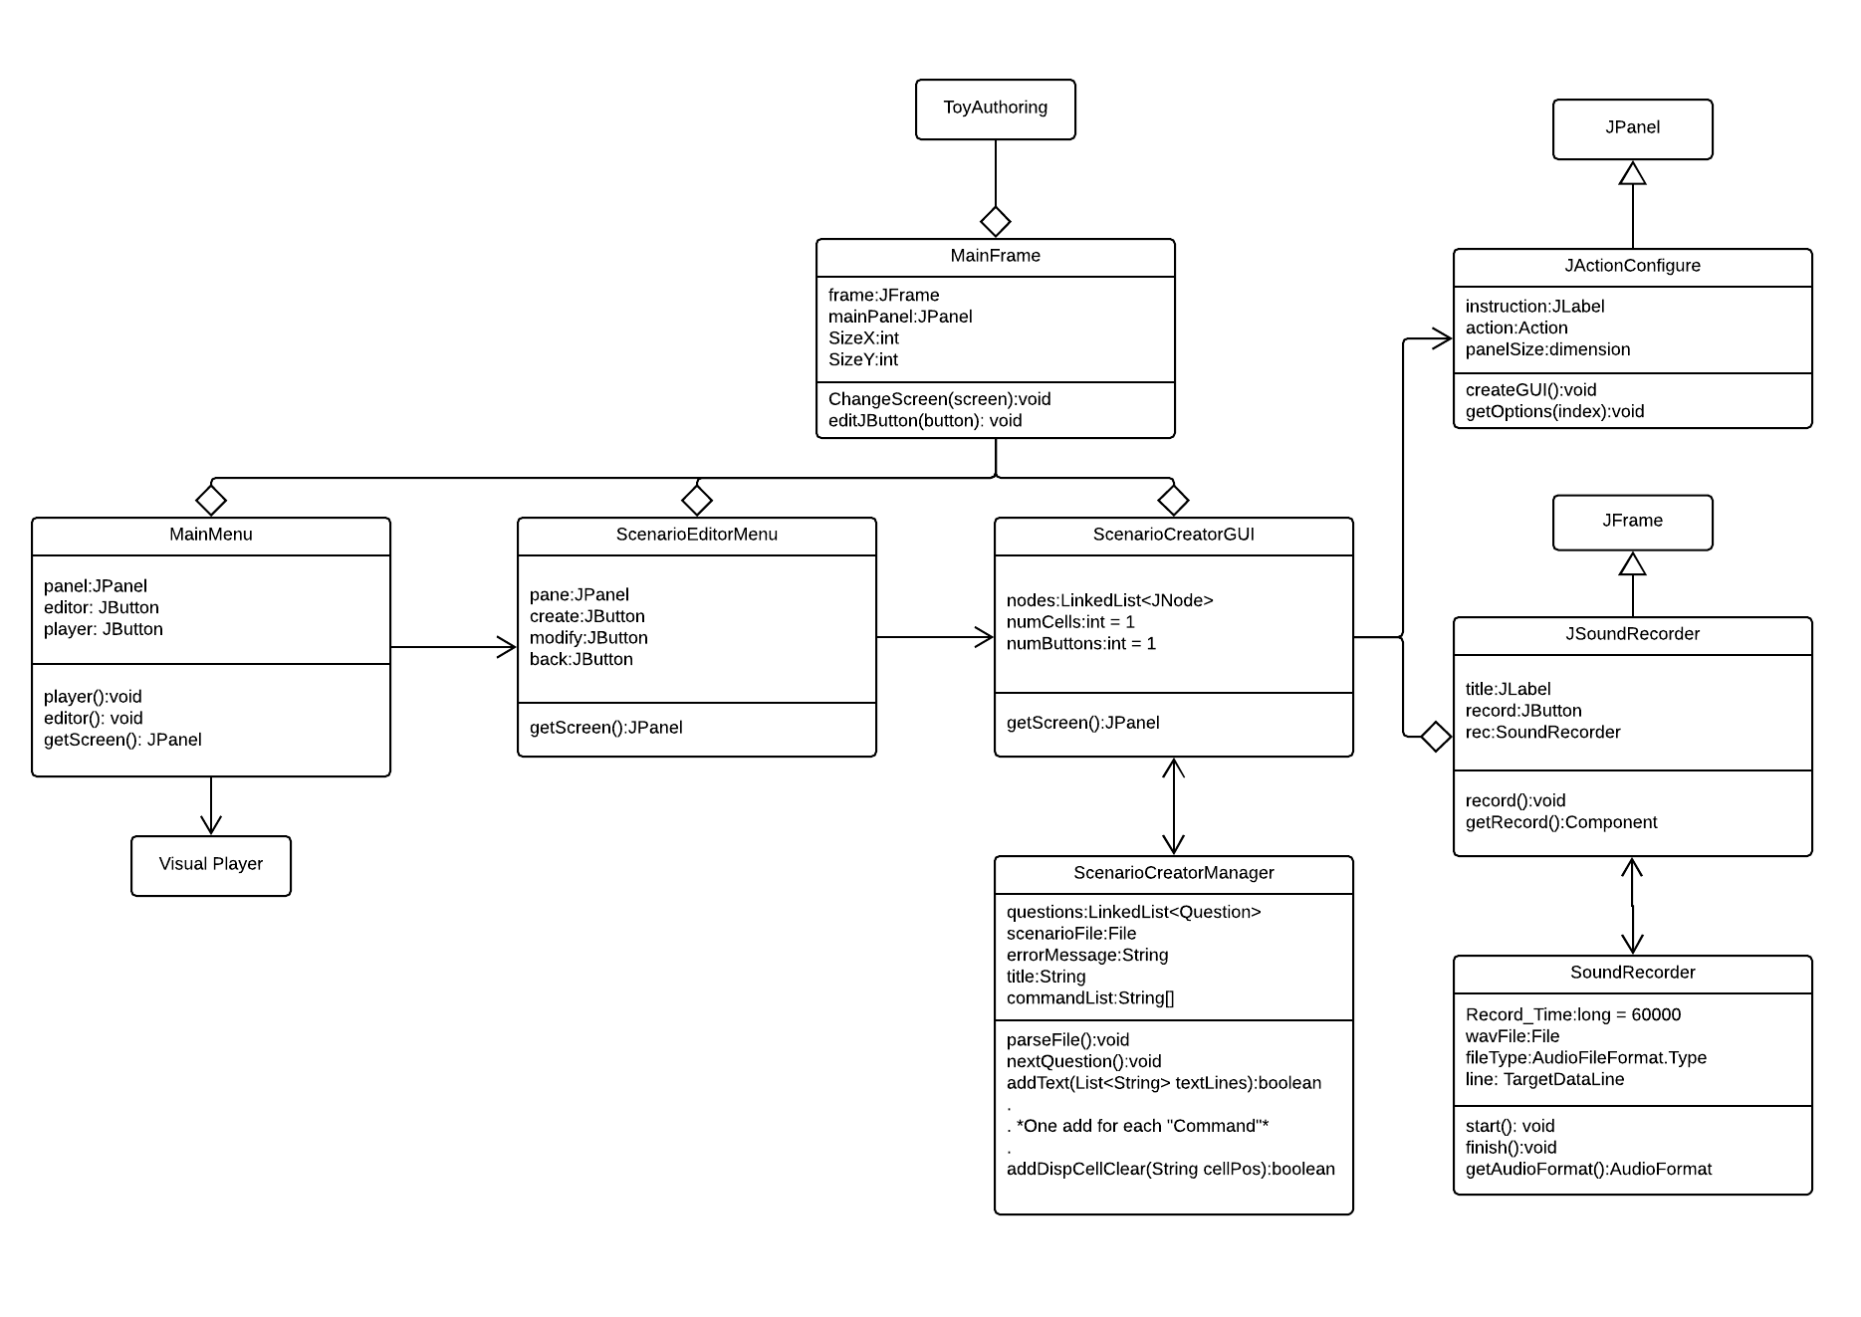The following is a high-level UML diagram indicating the class structures essential to the overall performance of the program

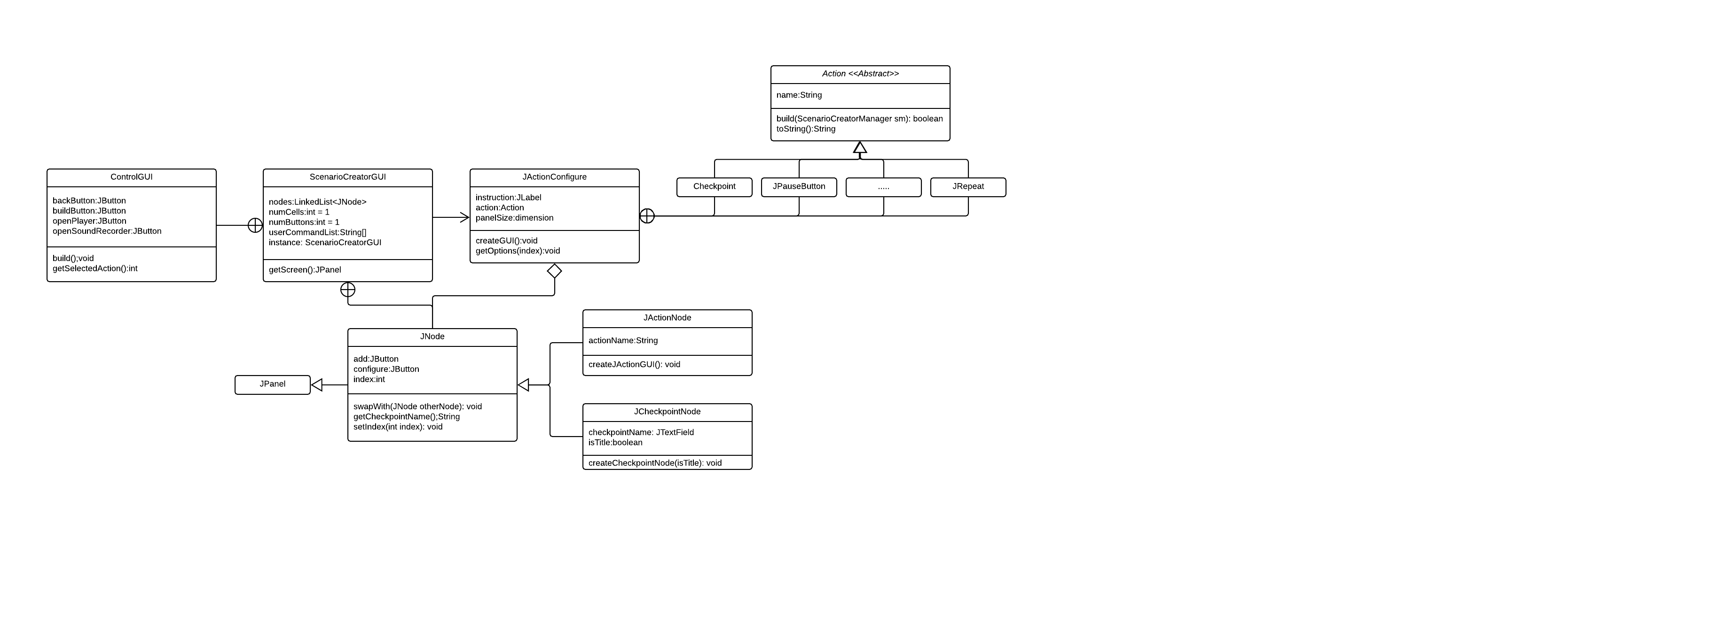The following is an important UML diagram describing the essential classes towards creating and editing scenarios